1. Two watt meters are used to measure power in 3 phase balanced load. Calculate P.F. when-
2. Two readings are equal and positive.
3. Two readings are equal and opposite

Solution :

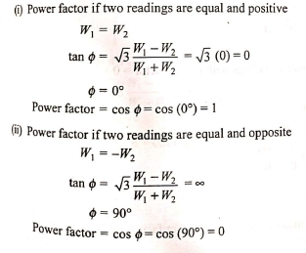

1. What will be the relation between readings of two watt meters when connected in 3 phase system to measure power under balanced load when i) P.F. is unity ii) P. F. is zero iii) P.F. is 0.5

Solution :

1. P.F. =1



1. P.F. =0



1. P.F.=0.5



